Computing Tools for Mathematics
Assignment # 01
Submission Deadline: 26-04-2021 Monday Till 5pm

Instructions: Solve the following problems using the concepts we have studied so far
- Display following sequence of stars:
* * * * *
* *
* *
* * * * *
* *
* *
* * * * *

Answer:

#include<iostream>
using namespace std;

main()
{
cout<<"*******\n""*\t*\n""*\t*\n""*******\n";
cout<<"*\t*\n""*\t*\n""*******\n";

}

Out put:
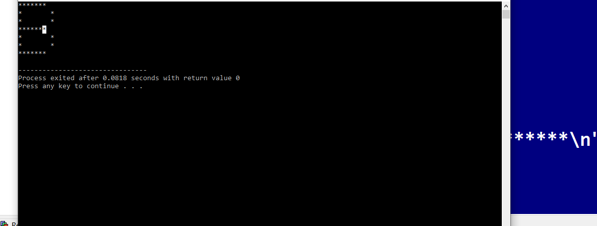

- Declare three variables a,b,c. give value as: a=15,b=4, c=a/b. Display the values of these variables on screen

Answer:

#include<iostream>
using namespace std;

main()
{
int a=15,b=4;
float c=0;
c=(float)15/4;
cout<<"\n\n\t\t*******************************";
cout<<"\n\n\t\tThe value after divide : "<<c<<"\n\n";
cout<<"\t\t*******************************";

}

Output:

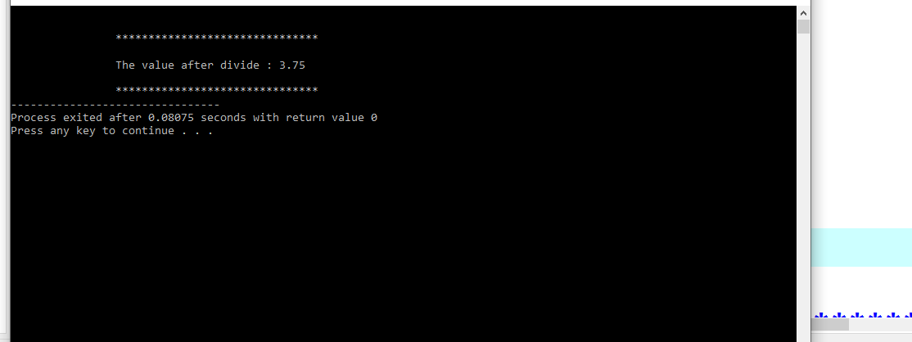

- Write a program that input five digit number like 12345 and display it on screen like following:

1 2 3 4 5

Answer:

#include<iostream>
using namespace std;

main()
{
int a,b,c,d,e;
cout<<"\n\n\t\t*******************************";
cout<<"\n\t\tEnter a number : \n";
cout<<"\t\t";cin>>a;
cout<<"\t\t";cin>>b;
cout<<"\t\t";cin>>c;
cout<<"\t\t";cin>>d;
cout<<"\t\t";cin>>e;
cout<<"\n\n\t\t*******************************";
cout<<"\n\n\t\tnumber before change : "<<a<<b<<c<<d<<e;
cout<<"\n\n\t\tnumber before change : "<<a<<" "<<" "<<b<<" "<<" "<<c<<" "<<d<<" "<<e;
cout<<"\n\n\t\t*******************************";

}

Output:

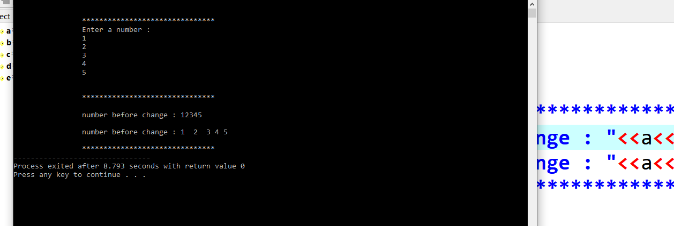

- Write a program that prints the sum, difference, product, quotient and remainder of two integers. Initialize the integers with the values 60 and 7 i.e. The sum is 67

The difference is 53

Answer:

#include<iostream>
using namespace std;

main()
{
int a,b;
cout<<"\n\t\t*********************************";
cout<<"\n\t\tEnter the number : ";
cin>>a;
cout<<"\n\t\t*******************************";
cout<<"\n\t\tEnter the number : ";
cin>>b;
cout<<"\n\t\t*******************************";
int sum,diff,quo,rem,pro;
sum=a+b;
diff=a-b;
pro=a*b;
quo=a/b;
rem=a%b;
cout<<"\n\n\t\tThe sum of two value : "<<sum;
cout<<"\n\n\t\t*******************************";
cout<<"\n\n\t\tThe difference of two value : "<<sum;
cout<<"\n\n\t\t*******************************";
cout<<"\n\n\t\tThe product of two value : "<<sum;
cout<<"\n\n\t\t*******************************";
cout<<"\n\n\t\tThe quotient of two value: "<<sum;
cout<<"\n\n\t\t*******************************";
cout<<"\n\n\t\tThe remainder of two value : "<<sum;
cout<<"\n\n\t\t*******************************";

}

Output:

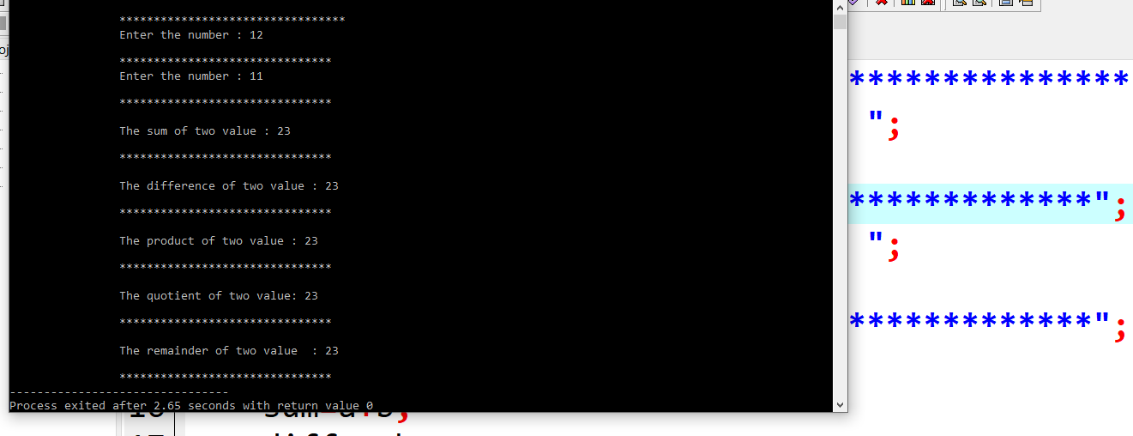

- Ask user to enter value in rupees and convert these rupees into dollar, ponds and euro and display them on screen. The latest conversion rate is following:
One dollar = 160 rupees
One pond = 210 rupees
One euro = 180 rupees

Answer:

#include<iostream>
using namespace std;

main()
{
int a,dollar,pond,euro;
cout<<"\n\t\t*******************************";
cout<<"\n\t\tEnter in rupees : ";
cin>>a;
cout<<"\n\t\t*******************************";
dollar=a/160;
pond=a/210;
euro=a/180;

cout<<"\n\t\tyour rupees after convert in dollar :"<<dollar;
cout<<"\n\t\t*************************************";
cout<<"\n\t\tyour rupees after convert in ponds :"<<pond;
cout<<"\n\t\t*************************************";
cout<<"\n\t\tyour rupees after convert in euro :"<<euro;
cout<<"\n\t\t*************************************";
}

Output:

